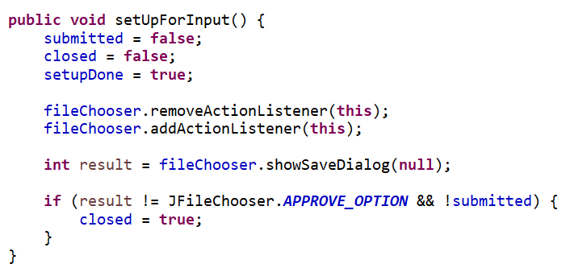
fileChooser.showSaveDialog will show the save version of the fileChooser and we set that to the result
This sets up the variables with their default values and then removes the actionListener from fileChooser in case it already has one from if it ran before. Then we add a new actionListener back.

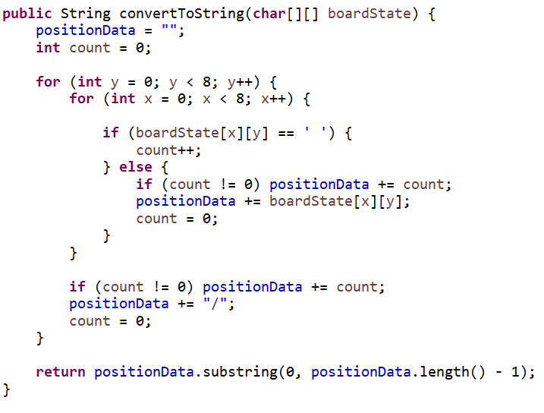
The string is then returned with the last line character removed so the last / is no in the string sent back
Then in between the nested for loops it checks if count is above zero and added that many to positionData if true after that a / is added to symbolize a new line and count is reset again. This is all done to put the array to BNF format
Then at each cell of the array it checks if it’s a space and if it is then count is incremented by one else it checks if the count is zero if not then count is added to positionData then the cell is added from the 2D array at the point to position data. Count is then reset.
Creates a nested for loop so it can go through the full 2D array of the list given.
This checks if the result is a approve option and that the answer is submitted if so, it sets it closed as true and closes this frame.

This sets up a filter for JFIleChooser so the user can only pick text Files (*.txt)
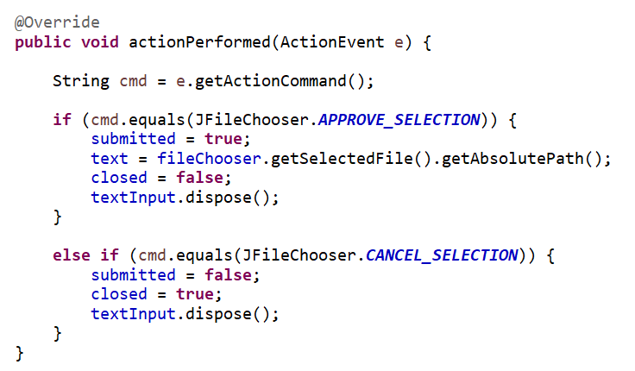
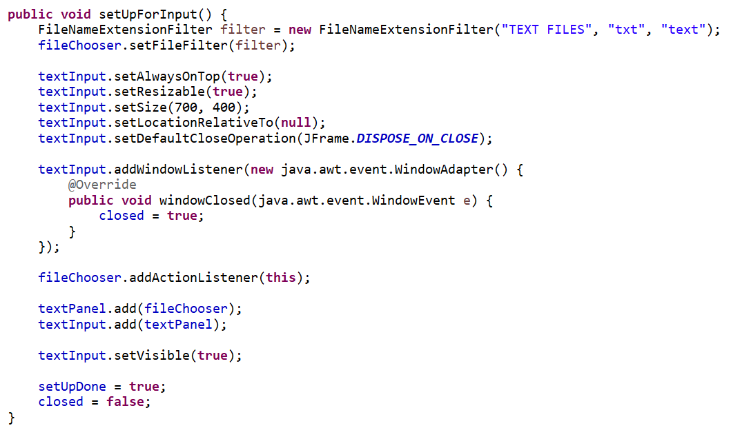
If the actionEvent equals the cancel button on the JFileChoser then closed is true, which will close this window and then the JFrame is dispose of.
Gets the actionEvent that triggered this and stored it as a string
If the actionEvent equals the approve section from JFileChooser then submitted is set to true and then the string text is set as the path to the selected file and closed is false and then the JFrame is disposed of.
Adds an action Listener to the JFileChoser then adds the fileCooser to the JPanel that is then added to the JFrame. The JFrame is then set as visible and the setUpDone is set to true as well as closed is set to false
This makes the frame adds a windows Listener it overrides the windows Closed method in the windows Listener and sets that to so closed equal true. Which will close the JPanel the way I need
Makes a JFrame that’s always on top to display the JFileChooser with the set size at the middle of the screen that gets disposed on closed
Creates a new JPanel with a grid layout of 0 to 8 to keep the grid format of a chess board. Then uses a Boolean variable to alternate the colours
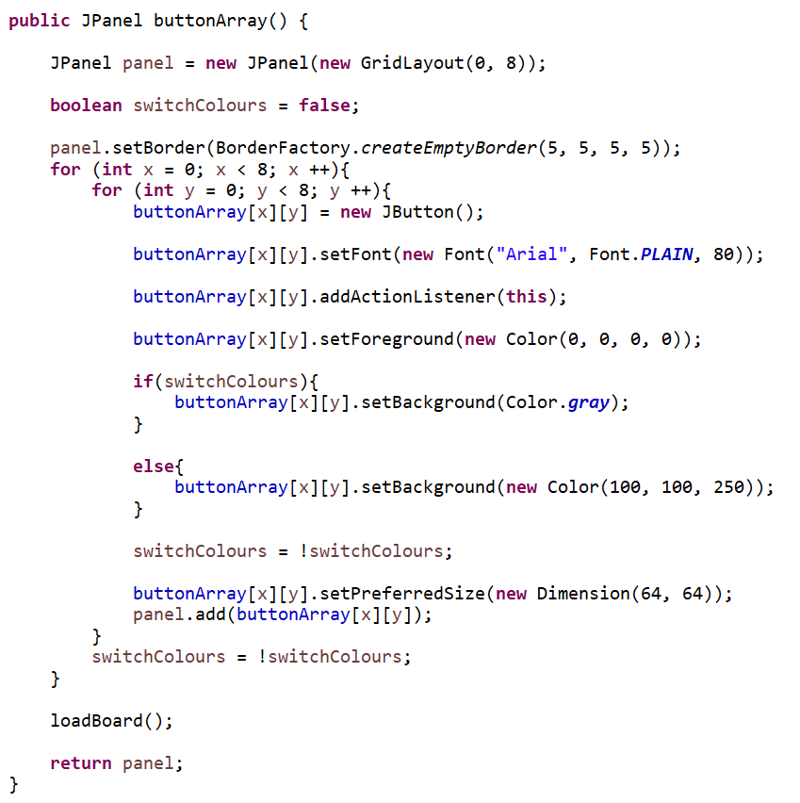
Creates each button needed using a nested for loop to create the button and uses the Boolean value to swich each time to alternate the colour and then the Boolean value is switched to its opposite and the preferred size is set, and the button is added to the panel and the board I loaded.

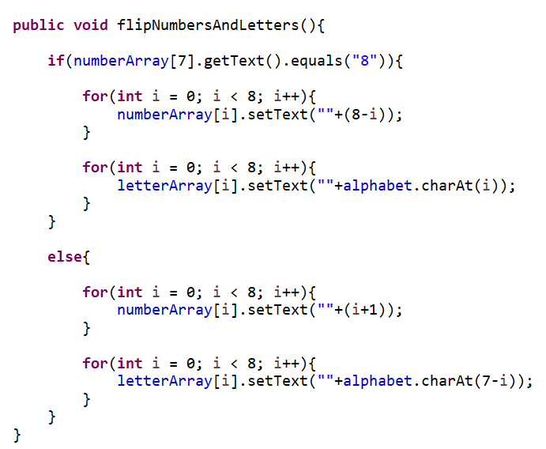
Uses two for loops to flip each side of the panel by re applying the text for each part but in the opposite way it was before
Checks which way the board is already to determine which way the board needs to be flipped

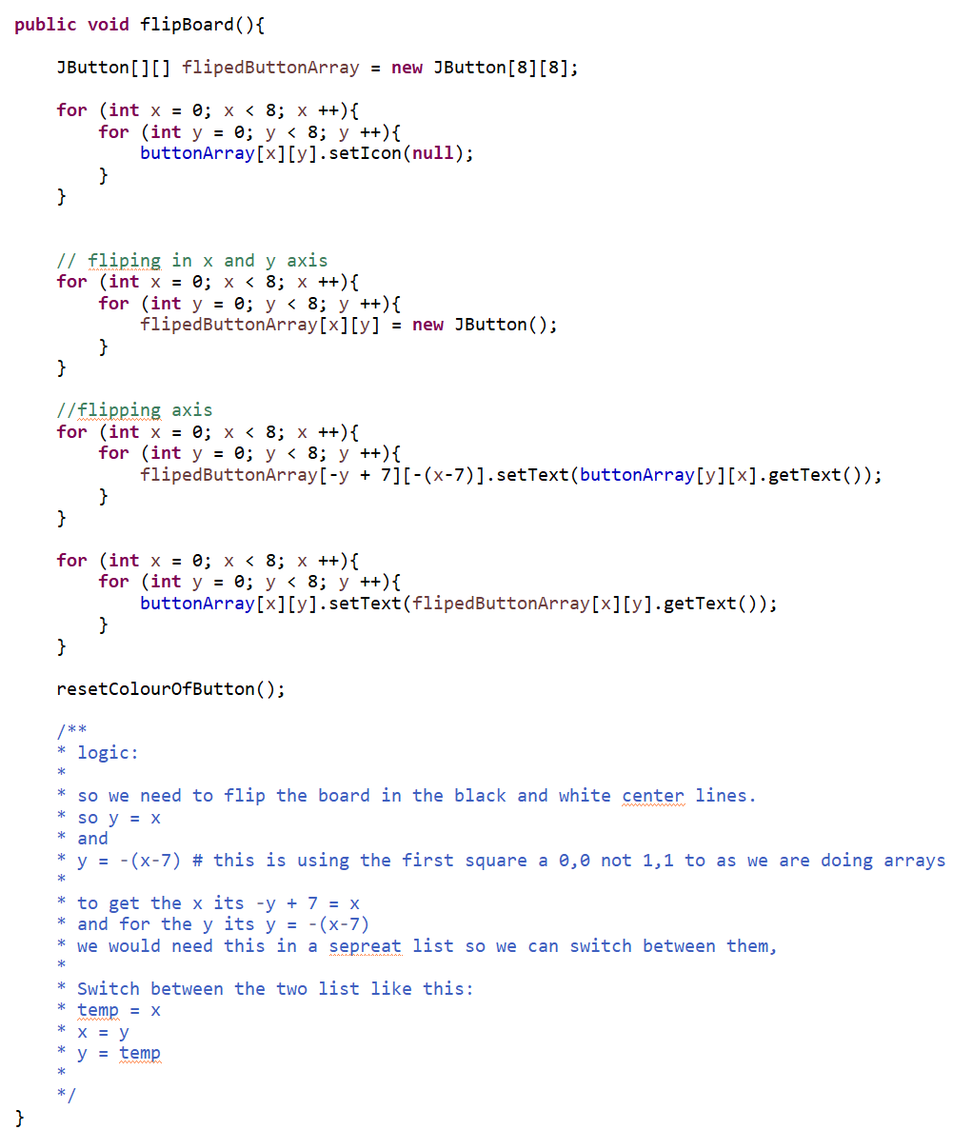
The third nested for loop flips it in the y = -(x +7) axis to flip the board entirely and then the flipped button array is set equal to the button array
I created a second JButton array to store the flipped board and then used a nested for loop to set the icons as null.
This second nested loop flips the buttons in the x and y axis as show in my logic statement.
This is the line of logic I used so I can easily trace the algorithm for debugging

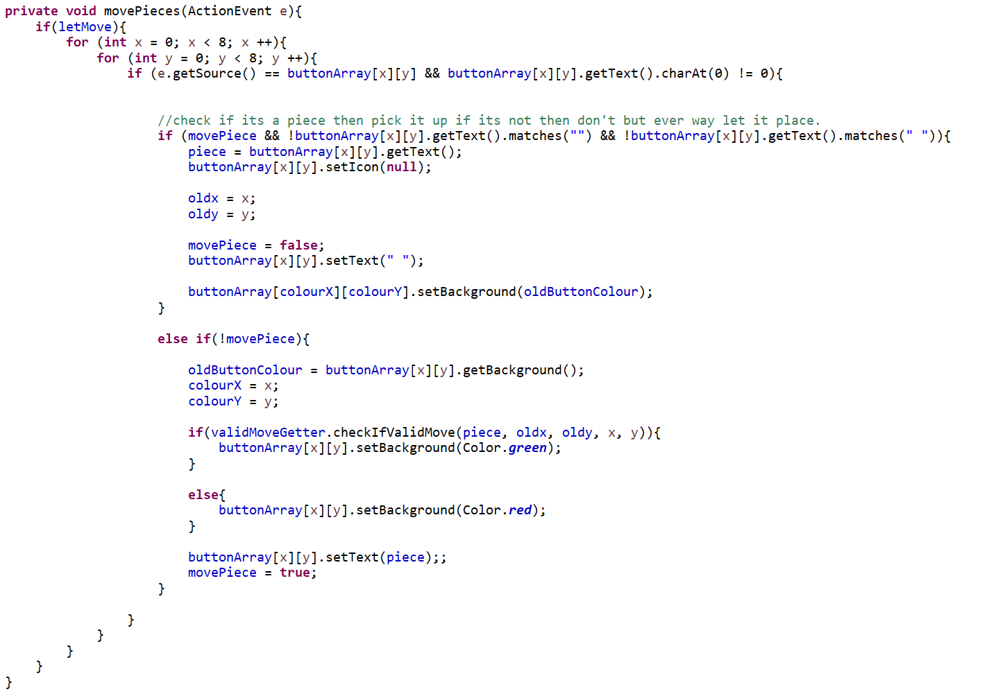
If this is the second part of movePieces then it gets the old colour of the button used for later and its x and y position so it can be used to re-apply its colour later and then uses the valid move getter to checks if its move is valid and if so then it changes its colour based of the out and sets the text of the panel to the pieces that was moved last and then sets movePiece as true for when a new piece is moved
First checks If this is the first piece that been clicked by using movePiece to check which part of movePiece is the function on then if its on the first part it gets the piece and the set the icons of it to null and apply the last button clicked its old colour as the button changes colour depending on if the previous move was valid or not
First it checks if letMove is on a it will be off it arrow mode is active then it enters a nested for loop to find the button clicked

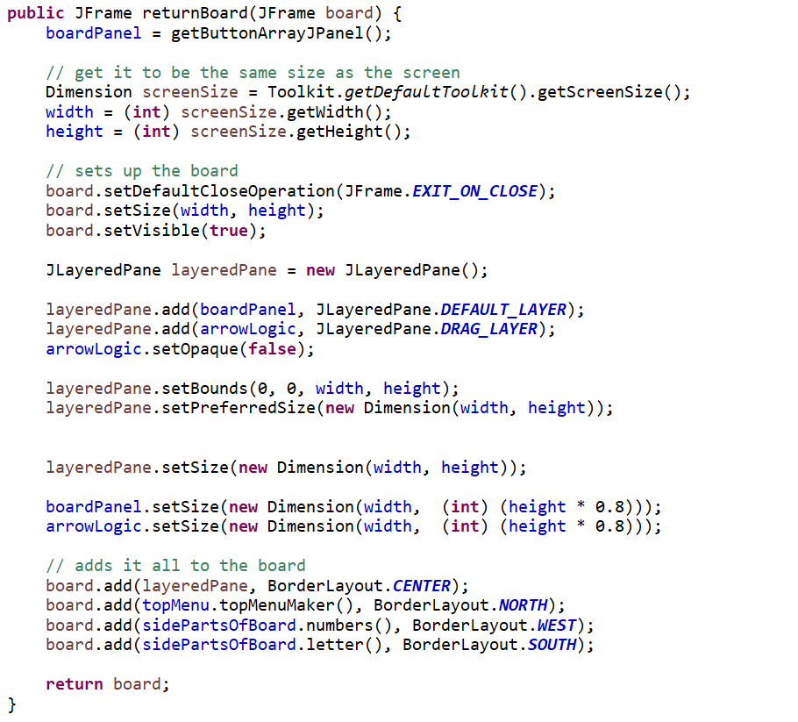
Addes everything to the JFrame and returns it up to the Frame Panel
Uses scaling of the screen size to put the panels on the screen right for every screen at 80% of the screen size
Creates the layered panel so the arrow logic can be seen over the board without replacing it but setting arrow logic as opaque.
Sets the size of the panel as its max as well
Makes the board closable and sets the size as the max it can be as well as making the board be seen
Gets the width and high of the screen so the program can be scaled to the user’s screen size.

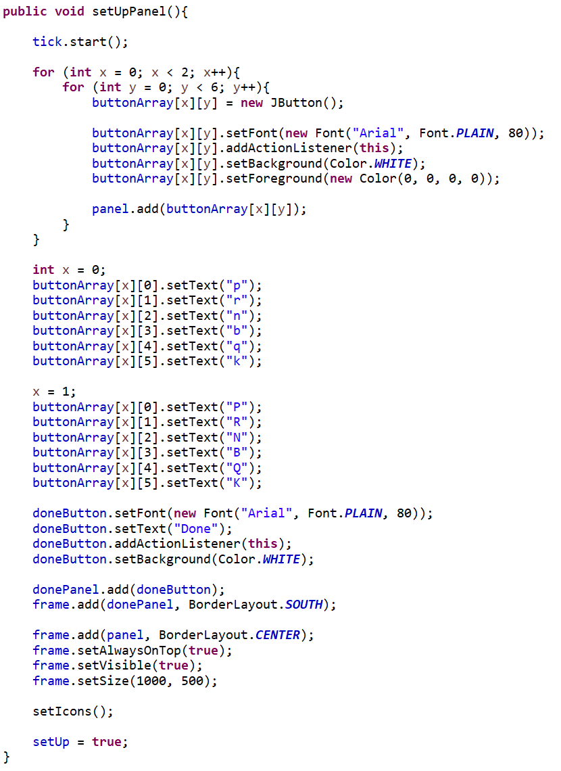
Makes a Done button when click will close the pop up and adds an action listener to it and sets the background to white. Then adds it to the panel and then frame.
Adds the main panel to the frame and then sets it to the very top and visible and sets the size.
Runs set icons to get the icons on to the buttons and makes setup true.
Each button is set to an individual text so the pieces can be all be there as they are all unique.
Creates the button array with the font and adds an action Lisner to it. Then the background is set to white, and the foreground is set to the same colour, so text is not shown but the images are. Then the button is added to the panel. This is all done in a for loop to do all the buttons needed.

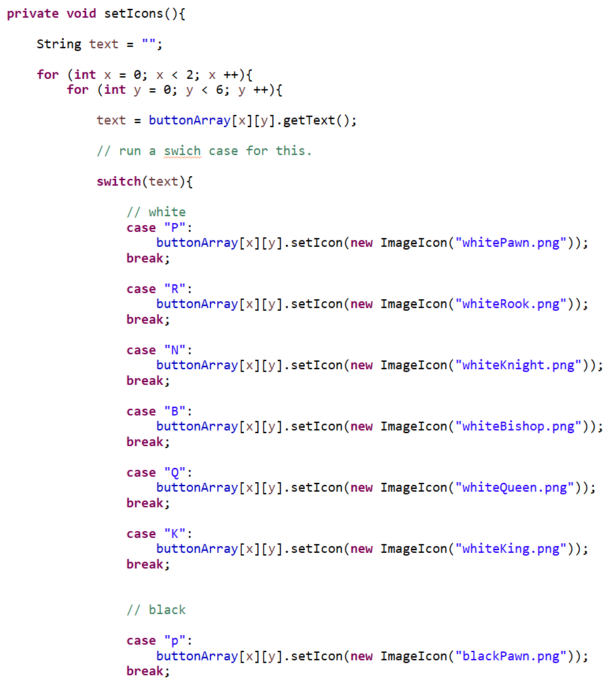
Uses switch case then when it is found we get the button that it’s at from the for loops internation and sets the icon as its icon that is saved in the files with the code so it can be loaded onto the button
Sets the text that needs to be used for the switch case to the buttons text it is displaying.
Iterates through the entire panel

Checks the buttons to see what been pressed. If done button is pressed, then done is set to true else it checks each button and then sets the name as the buttons text that was pressed
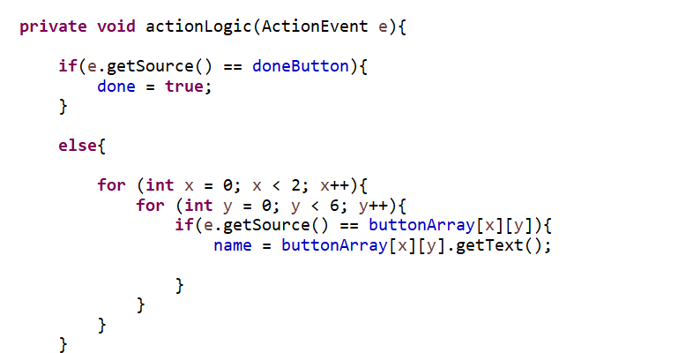
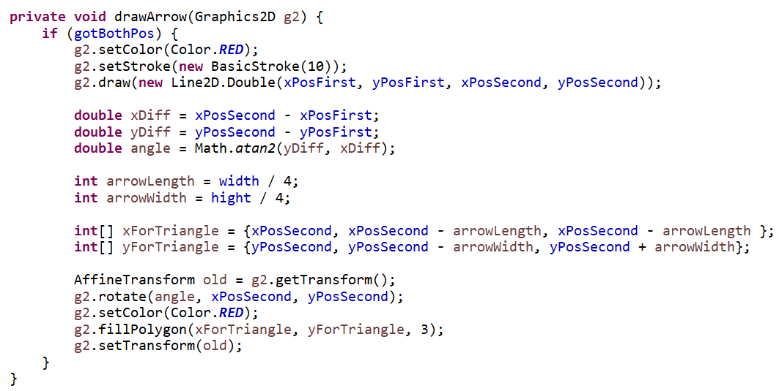
This translates the triangle with the angle using radiant and it set the arrows colour as red and draws the arrow as a full polygon with 3 sides.
Gets an int array for the triangles so g2 can draw it with the positions of x with the other sides with a fourth of the size of the square on ether side of its centre.
Gets the different of the positions on both position and gets the angle in radiant between them and then scales the arrows head to a fourth of width and hight of the button its position is in
Sets the graphic2D colour as red and sets the stroke size as 10. It also draws the straight line from the first positions to the second positions

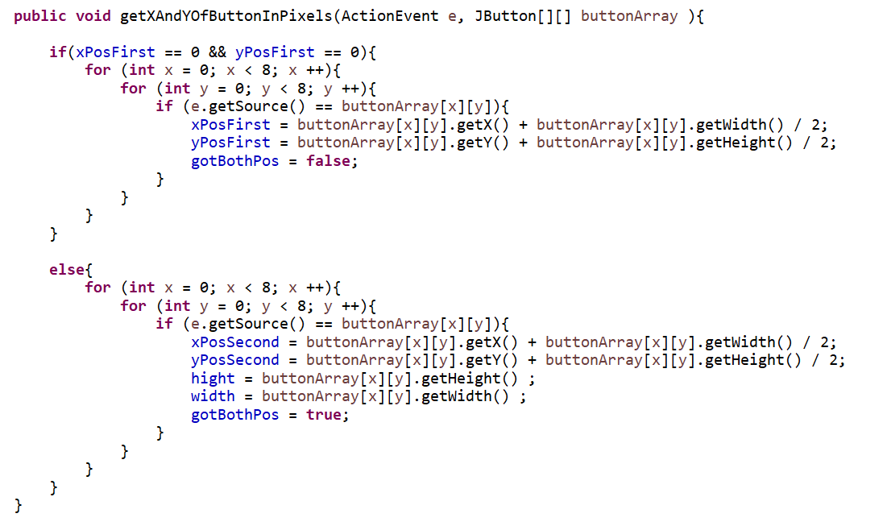
If we have the first x and y position, then it sets the second x and y position from its middle and then sets the Boolean variable getBothPos as true
Checks if we have the x and y position. If we don’t then it gets the x and y position from the middle button and makes it set so, get Both Positions s set as false

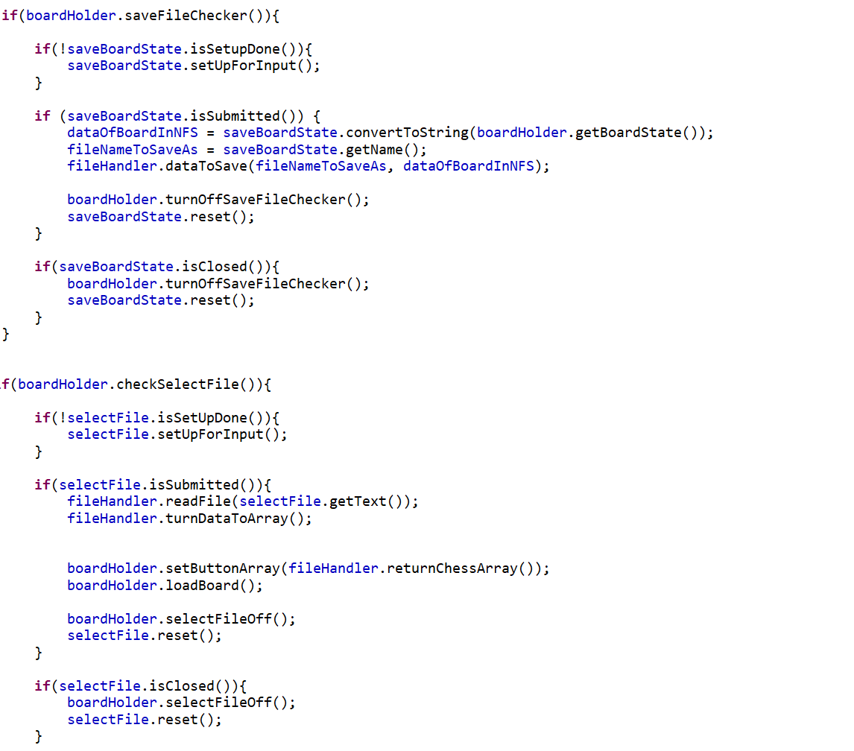
When the user has done what they need and the file has been created then the select file will make closed true making this true and resting the whole class for the user to run it again so they can save a new board.
When the select File mode is made and setup is done is has not happen the panel will be created from running this method
Gets the board and convers it to a string and saves it to a variable to parse it later and it also gets the files name from the FileChooser that the user typed to use as the name which also includes its file path. Then it is parsed into the method to create and save the file of that name. This happens when the user clicks the submit button
Turns off the save board and the topMenu so this loop doesn’t trigger when the user is finished.

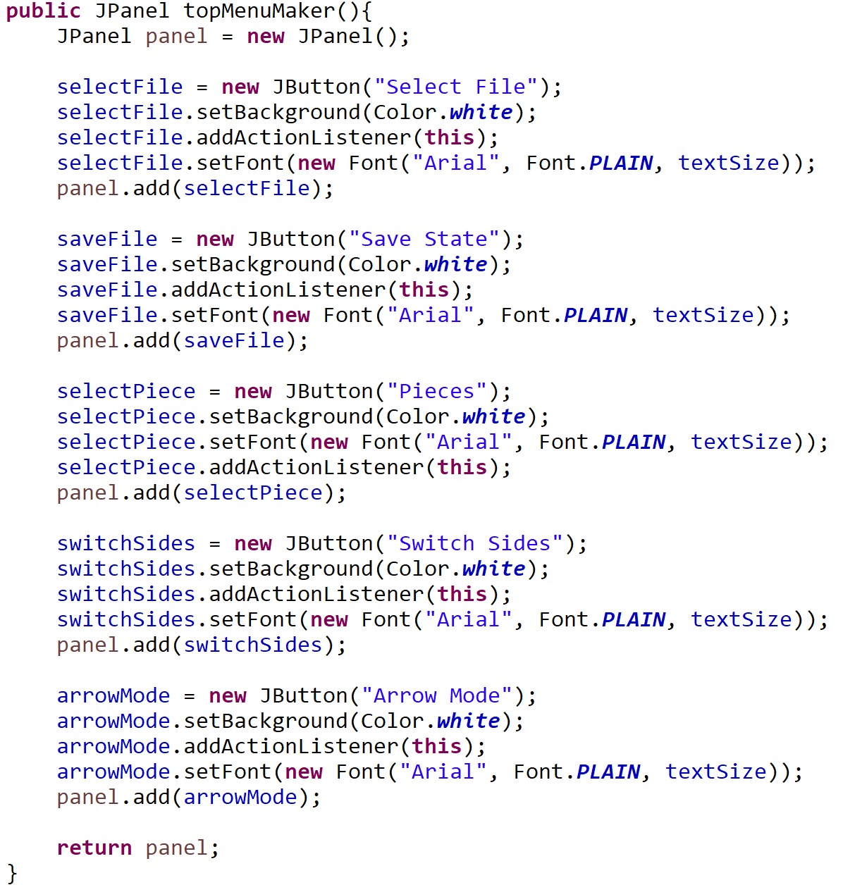
This method returns a JPanel full of the whole top menu panel and this method creates each button with there text and adds their action listener and then adds it to the panel. Then the panel is returned with all the buttons.

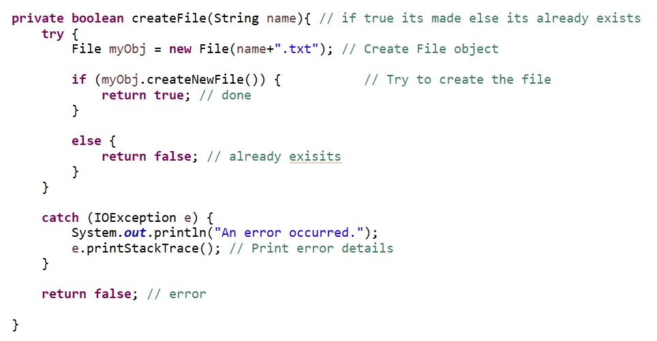
Takes a files name and then will try to create a file object with the name added with the extension .txt then it creates the file in an if loop and will return if it is true else it will return false if either an error happened or exists.

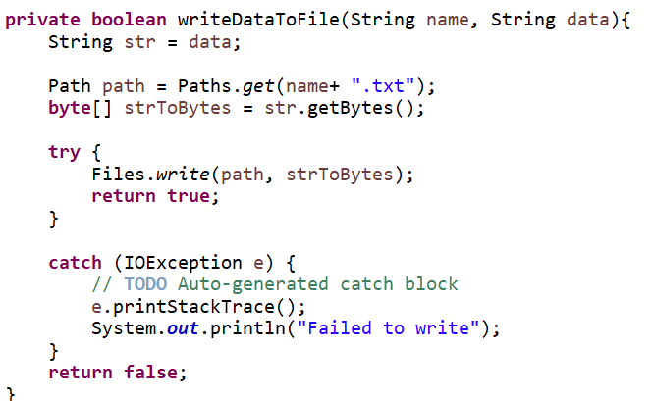
It tries to write the data to the file and then will return true if it worked else is false
Gets the path of the file from the name and adds the file extension. Then gets the data and converts it to an array of bytes

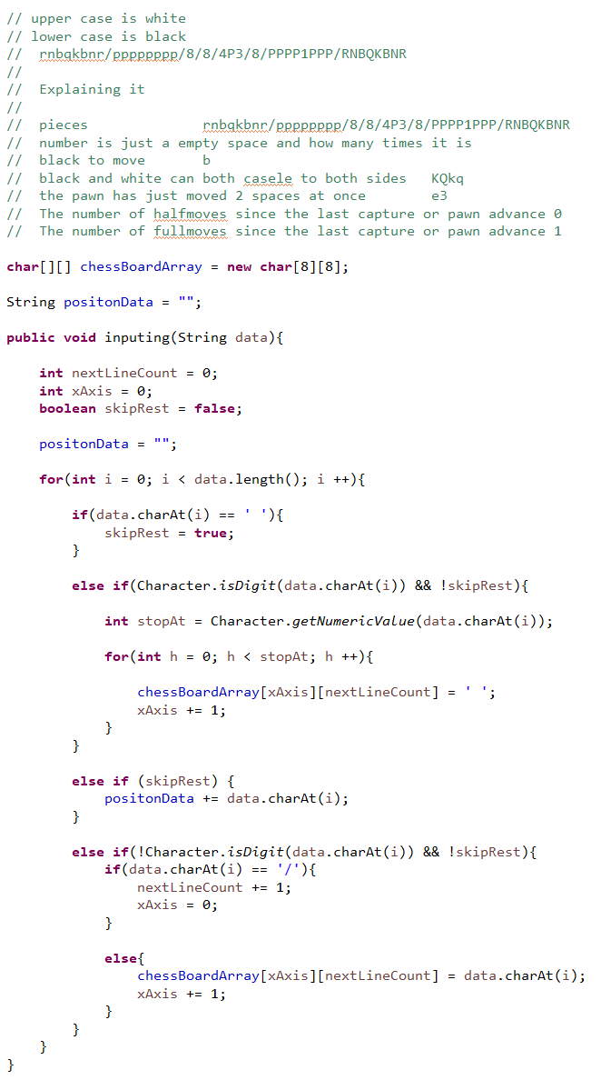
This uses an else if to check if the character is a digit and then if it is it repeated that character in the chess array for that many times and then increases the x Axis by one for each piece so there all on a new square
Finaly, it checks if its at the end of a line by check if it’s not a digit and then checks if it’s indicated a new line by ‘/’ if so it increments nextLineCount by one and resets X Axis to zero else it will add the next character to the array then increment the x Axis count by 1
If it’s the end of the string, then it adds the last part of the string to the array
Checks if it’s at an empty space which means its at the end of the data.
Notes on the format of FEN
Takes a string called data and then uses a for loop to iterate through the whole data and saves the info in the chessBoardArray and to do that it needs to process the data

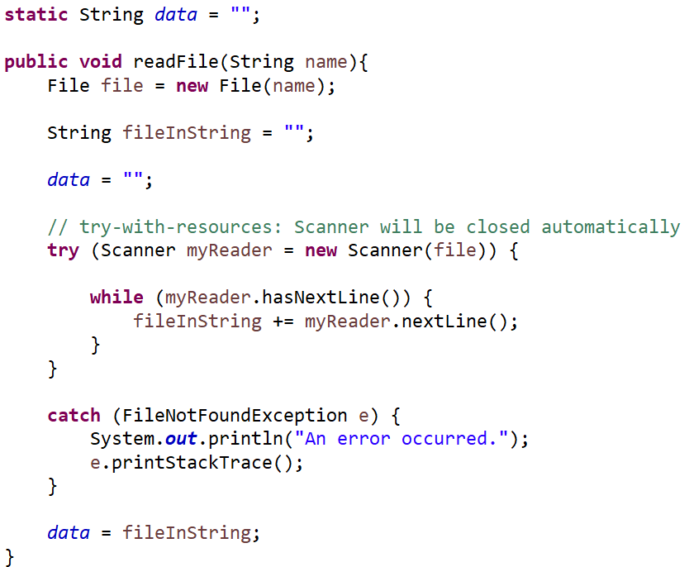
Next it tries to read the file with scanner and if it is successful then it will read all the lines and save it to the string else it will through an exception.
Then it puts the String to the static data so it can be uses elsewhere in the class
Starts with an empty string and the method takes a file name to read from and saves it as the file

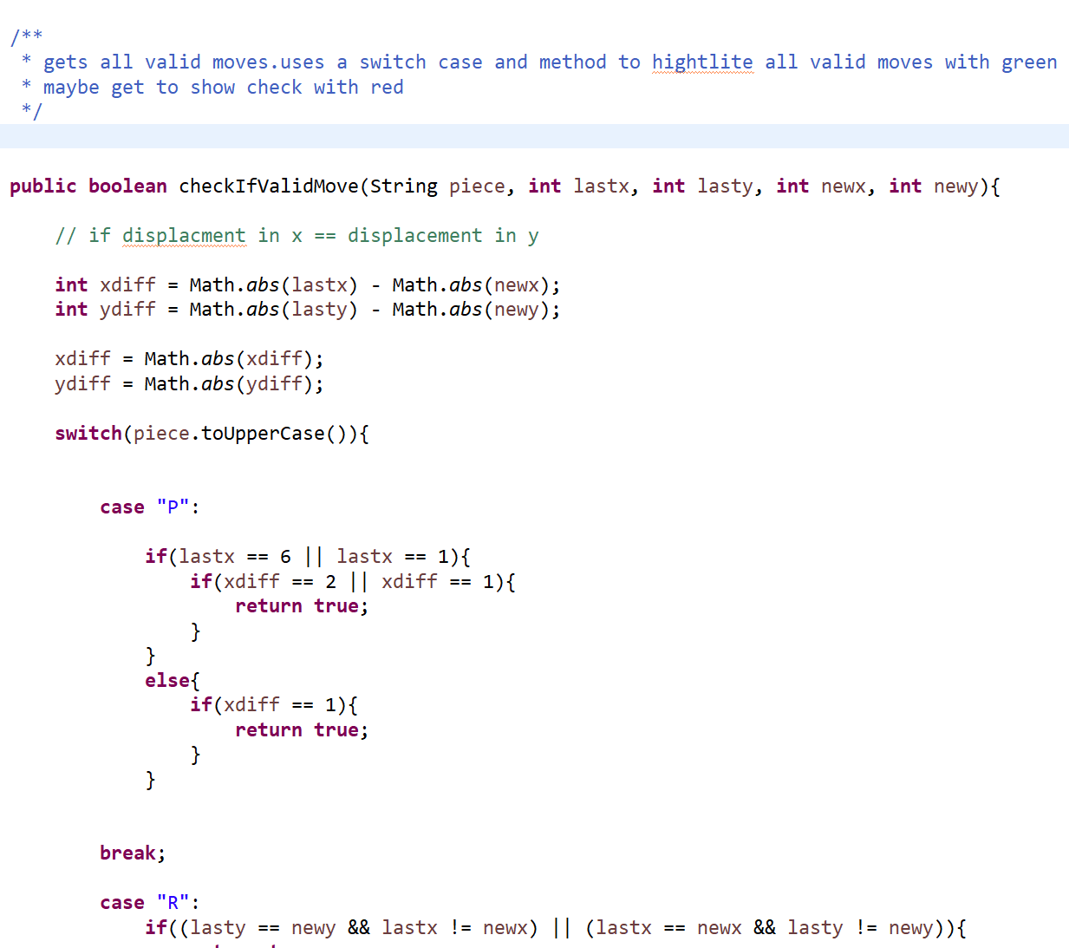
Uses the chess rules to see if the moves are valid. These first checks if it’s moved by two on their starting squares or if the pawn has moved by one on any other square and returns true if either are true else it will return false
Uses a switch case with all pieces turning to uppercase and then decides how to return if it’s a valid move or not.
Gets the name of the pieces as well as its last and new position
Calculates the x and y difference of the pieces and makes it all positive with the Math.abs so we can see the difference on both sides

